**Project Title:**

Analytical Dashboard Report for the Spread of Covid-19

**Contact Information:**

Steven Lin

(432)-209-8208

[stevens.email103080@gmail.com](mailto:stevens.email103080@gmail.com), [steven.lin03@bcmail.cuny.edu](mailto:steven.lin03@bcmail.cuny.edu)

**Supervisor:**

Troy Bailey

Assistant Coordinating Manager @ Woodhull Hospital Admitting Department

(718)-964-7491

[baileyt12@nychhc.org](mailto:baileyt12@nychhc.org)

**Abstract:**

In order to prevent the spread of future contagious viruses, we must analyze the behaviors and patterns within viruses of the past. The ideal goal for this project is to create an extensive dashboard that would assist in the analysis of the spread of Covid-19 virus in the United States. This dashboard would be able to visualize the spread of the virus throughout the pandemic and all the possible factors that may contribute to it. Factors that may be considered for this project include population, state politics, geographical borders, airline traffic, etc. These factors will be put through analysis to find whether there is correlation with the spread of Covid-19 and if there is correlation, the degree of correlation. Completion of this project would require designing an effective dashboard, data analysis software, data sets regarding Covid-19, and data visualization software.

**Tools:**

I will utilize functions that Tableau offers, possibly Excel, and datasets I find to be useful.

**Diagram:**

Since my project will not be on developing software, but rather a dashboard, my diagram will be on the process of data analyzation and integration. The process will start with data processing. After the dataset of a specific factor has been processed, it will run through a correlational analysis to find whether there is a relationship or not. Next, we would group data into similar clusters to further determine the nature of the relationship. This process of clustering data will be done through grouping of datasets based on the category of each dataset (Figure 2). Then we would run a cohort analysis to find out the degree of influence each data cluster has. Lastly, we would run a cycles analysis on all datasets together to see if there are any patterns present that should be addressed.

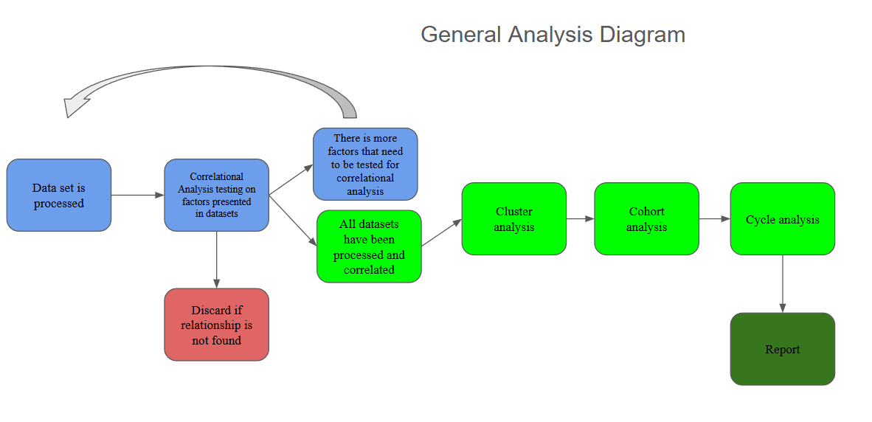

*Figure 1. Data Process/Analytic Diagram*

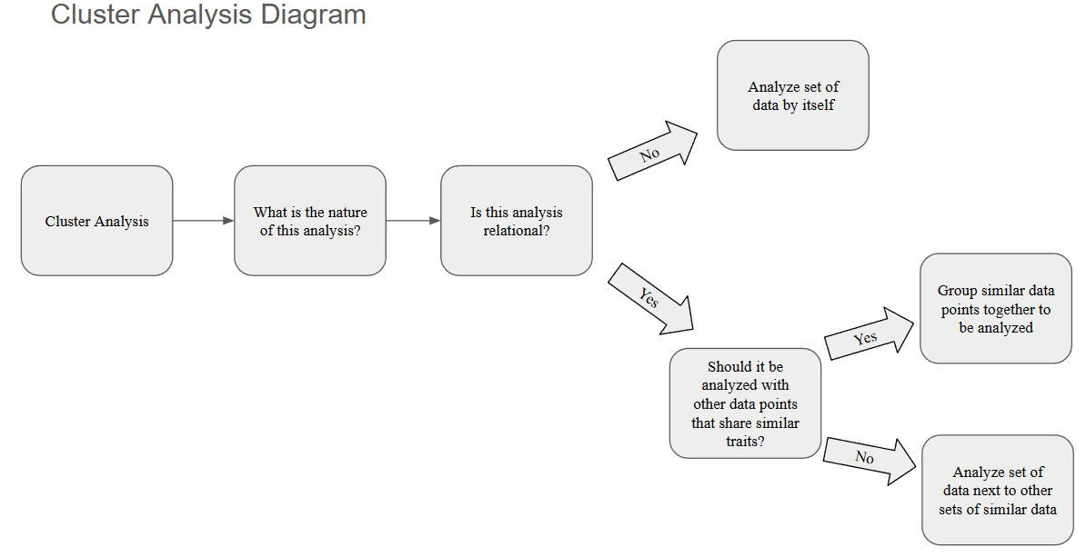

*Figure 2. Cluster Analysis Process*

**Tentative Schedule:**

The tentative plan schedule that I will follow is as (subject to change):

**Weeks 1-3:** planning project and gathering the information needed.

**Weeks 4-5:** Learn the basics of Tableau and begin processing of datasets and preparing analytical processes.

**Weeks 5-7:** ground level designs of the dashboard, setting up demo 1 and preparing for live presentation.

**Weeks 8-10:** add finishing touches on analytical processes and start on the map chart along with brainstorming ways to visualize data through trial and error.

**Weeks 11-12:** work on demo 2 and presentation slides.

**Weeks 13-15:** finish up designing and implementing data visualization processes. Review project to ensure it is what I envisioned. Prepare the final presentation and submit the finished project.

To start this project, I would plan and gather all datasets I could possibly want to include in my dashboard while I learn the basics of Tableau. After I’ve collected the datasets, data processing will begin when I have a decent understanding of how to do so in Tableau. Preparation of analytical procedures will follow after I understand what tools are provided for me in Tableau. While in the process of analyzing data, I will most likely start to design prototypes of how I would envision my dashboard to look. This would be used along with other concepts in my demo 1 and live presentation. After my demo 1 and first presentation, I would finish up with the analytical processes and start on the extensive map chart. I want this map chart to be the focal point of the dashboard so I will be investing a hefty amount of time to learn to do what I want it to do and implement it. Then after the map chart is done, I will utilize other data visualization techniques to help support the map chart. Hopefully, I can finish this before demo 2 so I could include all of these new features in it. While I prepare demo 2, I would also start presentation slides. The last two weeks should give me ample time to fully design and implement modern data visualization techniques to finish up my dashboard. After I am finished, I will prepare for the final presentation and submit the final project. In order to achieve all of this, my goal is to dedicate at least 15 hours per week for the project if not more.

**Data Sources:**

Datasets on Kaggle

CDC.gov

Possibly other sources

**Use Cases:**

The only use case for a dashboard such as this is to use it as a data visualization to draw conclusions on data.